PIZZA SALES SQL QUERIES
A. KPI’s
1. Total Revenue:
SELECT SUM(total_price) as total_revenue from pizza_sales;
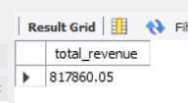
2. Average Order Value
SELECT SUM(total_price) / COUNT(DISTINCT order_id) as avg_order_value from pizza_sales
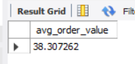
3. Total Pizzas Sold
SELECT SUM(quantity) as total_pizza_sold from pizza_sales
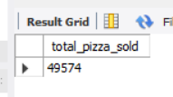
4. Total Orders
SELECT COUNT(DISTINCT order_id) as total_orders from pizza_sales
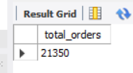
5. Average Pizzas Per Order
SELECT SUM(quantity) / COUNT(DISTINCT order_id) as avg_pizzas_per_order from pizza_sales
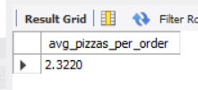

B. Daily Trend for Total Orders
SELECT DAYNAME(order_date) as order_day, COUNT(distinct order_id) AS total_orders from pizza_sales
GROUP BY DAYNAME(order_date)

Output:
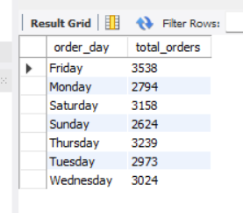
C. Hourly Trend for Orders
SELECT HOUR(order_time) AS order_hours, COUNT(DISTINCT order_id) AS total_orders
from pizza_sales
GROUP BY HOUR(order_time)
ORDER BY HOUR(order_time)
Output
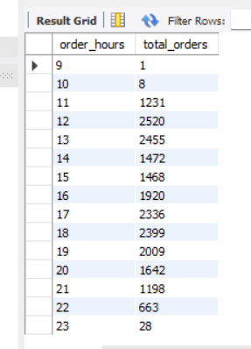

D. % of Sales by Pizza Category
SELECT pizza_category, SUM(total_price) AS category_sales,
(SUM(total_price) / (SELECT SUM(total_price) FROM pizza_sales) )*100 AS percentage_sales FROM pizza_sales
GROUP BY pizza_category;
Output
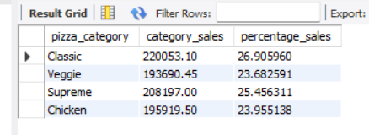
“It shows the contribution of each pizza category to total revenue, helping identify which category drives the most business.”
FOR JANUARY MONTH
SELECT pizza_category, SUM(total_price) AS category_sales,
(SUM(total_price) / (SELECT SUM(total_price) FROM pizza_sales WHERE MONTH(order_date) = 1) )*100 AS percentage_sales FROM pizza_sales
WHERE MONTH(order_date) = 1
GROUP BY pizza_category;

E. % of Sales by Pizza Size
SELECT pizza_size, SUM(total_price) AS category_sales,
(SUM(total_price) / (SELECT SUM(total_price) FROM pizza_sales ) )*100 AS percentage_sales FROM pizza_sales
GROUP BY pizza_size;

Output
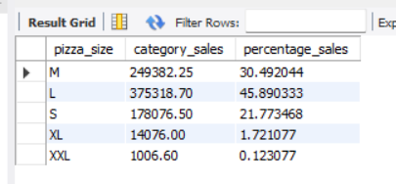
F. Total Pizzas Sold by Pizza Category
SELECT pizza_category, SUM(quantity) AS total_pizzas_sold FROM pizza_sales
GROUP BY pizza_category

Output
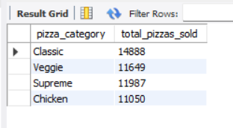
G. Top 5 Best Sellers by Total Pizzas Sold
SELECT pizza_name, SUM(quantity) as total_pizzas_sold from pizza_sales
GROUP BY pizza_name
ORDER BY SUM(quantity) DESC LIMIT 5
Output
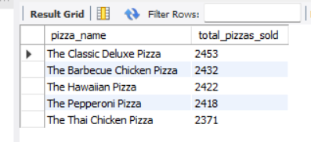

H. Bottom 5 Best Sellers by Total Pizzas Sold
SELECT pizza_name, SUM(quantity) as total_pizzas_sold from pizza_sales
GROUP BY pizza_name
ORDER BY SUM(quantity) ASC LIMIT 5

[ FOR AUGUST MONTH -
SELECT pizza_name, SUM(quantity) as total_pizzas_sold from pizza_sales
WHERE MONTH(order_date)=8
GROUP BY pizza_name
ORDER BY SUM(quantity) ASC LIMIT 5 ]
Output
